COAL Lab 3
Name=laraib salam
Sap id 61996
Tasks 1
.org 100h
.data
.code
main proc
mov dl,'a'
mov ah,2
int 21h
mov dl ,10
mov ah,2
int 21h
mov dl ,13
mov ah,2
int 21h
mov dl,'b'
mov ah,2
int 21h
mov dl ,10
mov ah,2
int 21h
mov dl ,13
mov ah,2
int 21h
mov dl,'c'
mov ah,2
int 21h
mov dl ,10
mov ah,2
int 21h
mov dl ,13
mov ah,2
main endp
end main

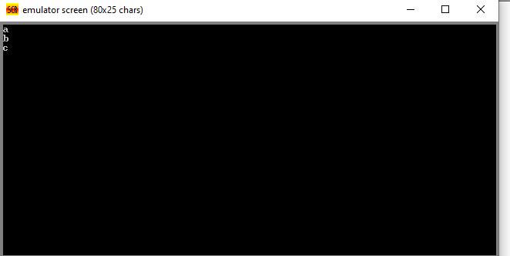

Tasks 2
.org 100h
.data
.code
main proc
mov d l,'l'
mov ah,2
int 21h
mov dl,'a'
mov ah,2
int 21h
mov dl,'r'
mov ah,2
int 21h
mov dl,'a'
mov ah,2
int 21h
mov dl,'i'
mov ah,2
int 21h
mov dl,'b'
mov ah,2
int 21h
main endp
end main

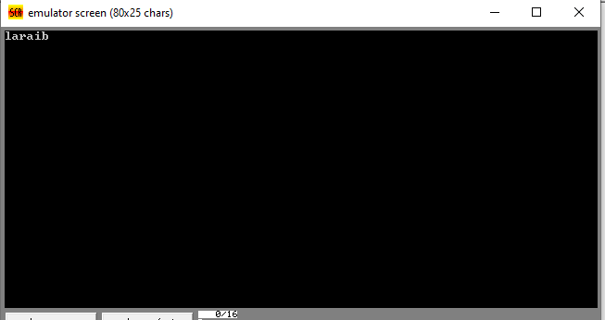

Tasks 3
.org 100h
.data
.code
main proc
mov ah ,1
int 21h
mov dl,al
sub dl,32
mov ah,2
int 21h
main endp
end main

